I redo the homework of Question 3.1 again.
So here's my new GAP: A bag that can carry (1) my changing clothes, (2) cleansers without wetting them when taking shower.
(Because the bathrooms in my dorm are too small, and the shelves are somewhat low)
So the following two pictures are the new process I made about the gap:

(1)DECOMPOSTION & (2) TEN CONCEPTS
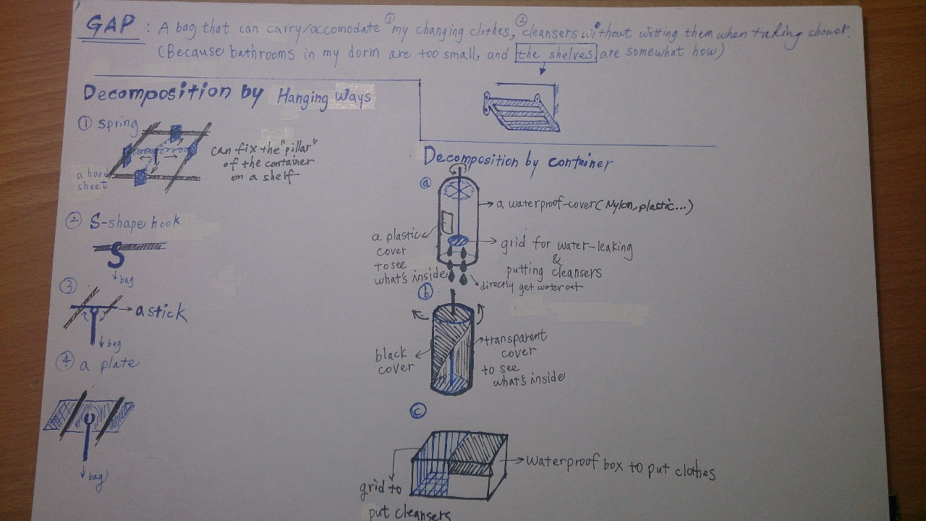
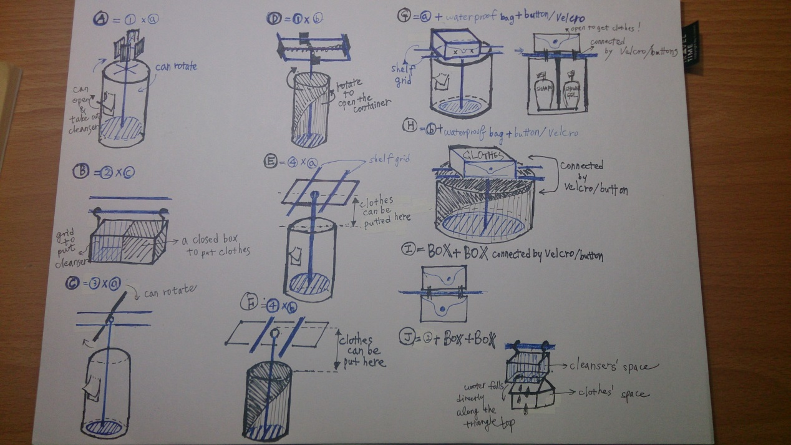

PHOTO OF A BATHROOM SHELF IN MY DORM
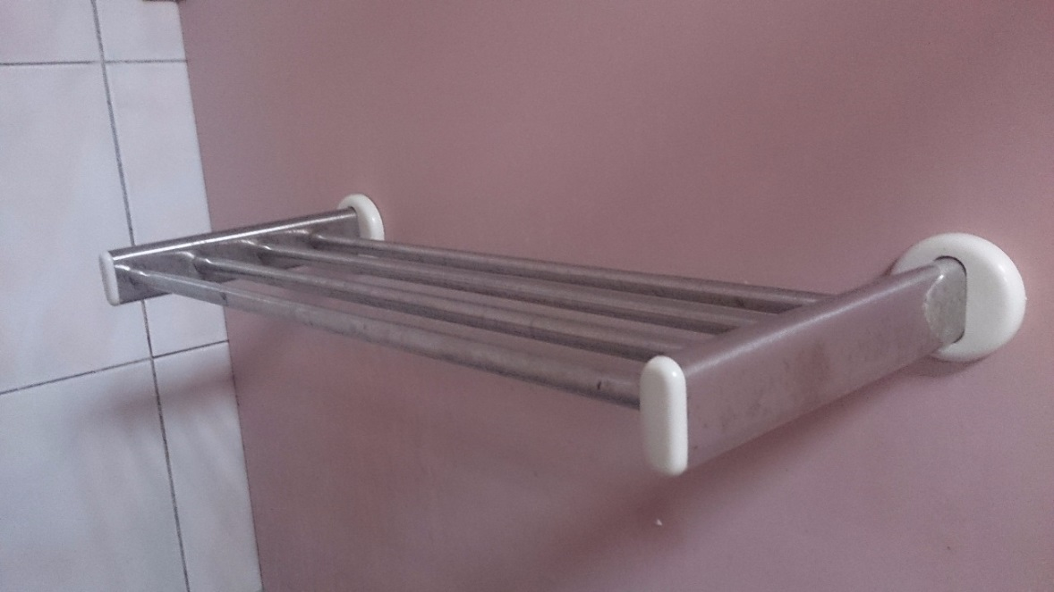
I personally favor over the element "elegance", so that I decided to make a cover of simple black and white. But Later on I found out that eyesight cannot penetrate color white, that is, I cannot see what's inside the box. So i changed it into transparent things like plastic.

